Most worker ants are slackers
David Shultz
6 October 2015 5:15 pm
http://news.sciencemag.org/plants-animals/2015/10/most-worker-ants-are-slackers

Ants and bees have reputations as efficient team players. In Temnothorax rugatulus—a small brown ant found in pine forests in North America—division of labor is common, with workers specializing in tasks like foraging, building, and brood care. But new research shows that many ants in a colony seem to specialize in doing nothing at all. To get a closer look at how these ants filled their time, researchers marked every member of five lab-based colonies with dots of colored paint. Over the course of 2 weeks, a high-definition camera recorded 5-minute segments of the ants in action six times a day, capturing their behavior (or lack thereof). Out of the “workers,” 71.9% were inactive at least half the time, and 25.1% were never seen working. A small fraction of the ants, just 2.6%, were always active during observation, the researchers wrote last month in Behavioral Ecology and Sociobiology. Previous studies have postulated that inactivity might be temporary, with ants working in shifts dictated by circadian rhythm. But the new results show that the lazy workers stay lazy no matter the time of day. According to the team, this suggests that inactivity isn’t merely a break between tasks, but might be an important part of the ants’ division of labor. Just what part remains unclear, but one theory is that the inactive ants are either too young or too old to work. Future studies over longer periods of time could capture the ants switching between busy and lazy modes.
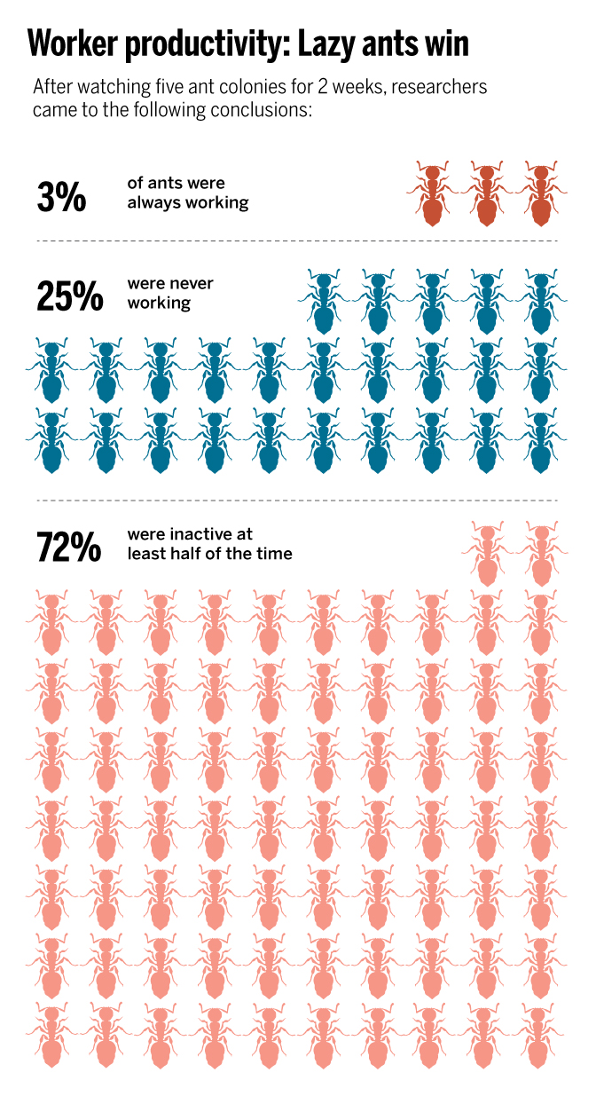
Science| DOI: 10.1126/science.aad4678

